News Time

Web Programing class project 2021

An-Najah National University Faculty of Engineering

Department of Computer Engineering



Web Programing Course - 10636316 **News Time**

Instructor: Dr. Sufian Samara

**Members of project :** Ameer yahia yaish - Abed al-kareem salah

|  |  |  |  |  |
| --- | --- | --- | --- | --- |
| Student Name in English | Student Name in Arabic | Student ID | Section | Work percentage |
| Abed al-kareem salah | عبد الكريم سمير صلاح | 11819572 | 11-12.5 | %50 |
| Ameer yahia yaish | أمير يحيى نصرت يعيش | 11819809 | 11-12.5 | %50 |

9/5/2021

---------------------------------------------This section is intended for the Instructor---------------------------------------

|  |  |
| --- | --- |
| **Topic** | **Mark** |
| Project Idea |  |
| Project Complexity |  |
| Project Tools |  |
| Project Requirements and Modeling |  |
| Project Discussion |  |
| Project Completeness |  |
| Project Output Results or reporting |  |
| Project Administration and Management |  |
| Project Report |  |
| Team work |  |
|  |  |
|  |  |
|  |  |
|  |  |
|  |  |

# Abstract :

#### The project talks about a web page that reviews a set of news in a very simplified way. The page is divided as sections like sport , international, travel, etc… and each section includes its own news , in addition to that there is a collection of ads , video slider and pictures which are linked to a web news videos and pictures, what makes this site distinguished is that there is an admin page that controls users types and the added news.

Contents

Abstract : 3

Introduction : 5

Project Requirements : 6

Tools used in the project : 7

Project in UML : 8

Discussion about project GUI : 9

**1. Main Page 9**

A. video slide block 10

**B.** **Travel section, ads and web new block**  11

**C.** **last block and footer of main page**  12

**2.** **News Sections 13**

**3. About us 14**

**4.** **Contact us 15**

**5. Covid block 16**

**A.**  **Main covid page** 17

**B.**  **Protect and Vaccine blocks**  18

**C.** **Chart and Statistics block**  19

**D.** **footer of Covid page**  20

**6.** **Login to control panel Page 21**

**7.** **Control Panel and Admin Page**  **22**

**A.** **News Control**  23

**B.** **Chart control**  24

**C.** **Contact and users messages**  25

Conclusion : 26

References : 27

# Introduction :

This site was made for users as a page for browsing different news locally or internationally , the admin can manage , arrange , delete , update the added news in a control panel page with simplified mechanism provided , the user can manage the news and search about a certain new added by the control panel . The insertion interface has been designed to be clear and simple to use so the user can be comfortable while inserting his news and users. In addition to that any user can contact with the admins of the site by messaging them in the contact us section.

The sections in this site provides all the required information that are related to a specified new like name of the new , content of it and its parent section.

The user can browse all news, advices and vaccines related to covid virus in lateral dedicated page, it contains the statistics of deaths, infected and recovered.

The rest of the page is filled with few ads , some videos related to web news sites and a section called around the world , in this section there is some photos as a gallery denoting to a different countries and its most famous cultures , food and places its widely known by it.

# Project Requirements :

Each admin user has an unique id, username and password that allows him to enter the site as an admin , this user can control news sections each new has a title, photo, adding time, content, name and its classified as one of the sections. Every section has an id and the name of the category.

Non admin users can contact admins by inserting in the contact section there name, subject ,their email address, and the message they want to send, admins can see their messages in the email section in control panel.

We keep tracking the number of recovered, infected and the deaths in the statistics part and these numbers can be updated in the chart section in control panel.

# Tools used in the project :

**we wrote the website using: HTML, CSS, SQL, JAVASCRIPT, and PHP , we have used port xampp as localhost , phpMyAdmin as data base manager , phpstorm program as a code editor and for report designing we used chart.js.**

* **PhpStorm for programing and code editing**
* **phpMyAdmin for database**
* **Draw.io for UML diagram**
* **Chart.js for report** **and statistics**

***Project in UML* :**

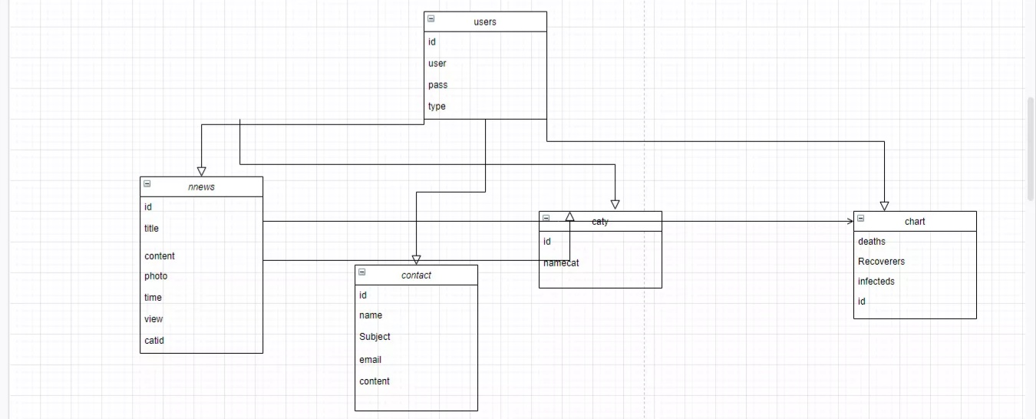

# Discussion about project GUI :

## **Main Page**

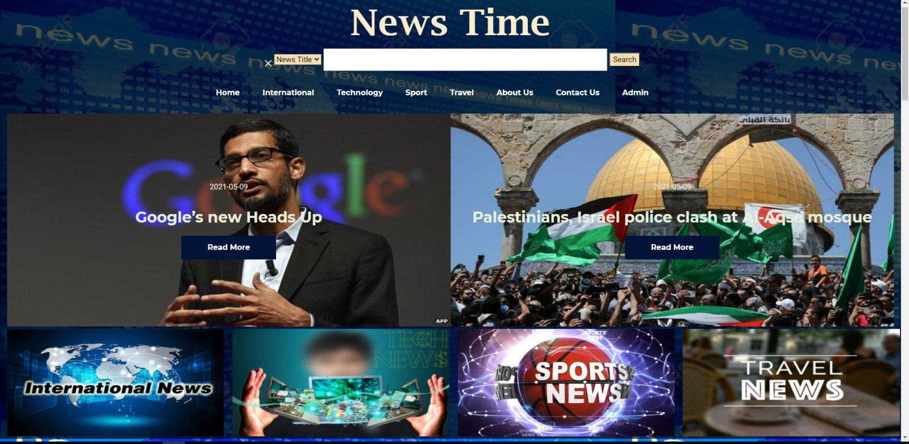

This is the first interface in the site , it includes a search button , user can search by any part of the new title or content of it .

Under of it there is all sections of news , contact us and about us section.

The recent added news in sections are displayed in the header with their title , if user clicks on read more button he will move to the intended new.

The pictures bar in the end is linked with external web sites for each section.

## **video slide block**

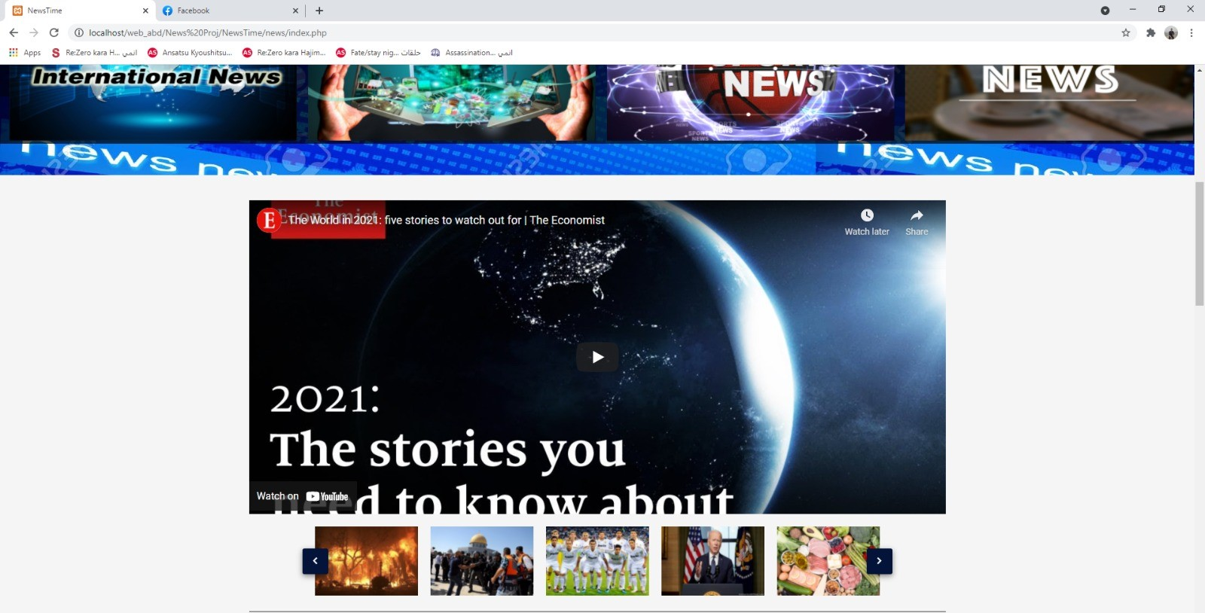

In this interface there is a slide bar contains different videos related to different web news on YouTube.

## **Travel section, ads and web new block**

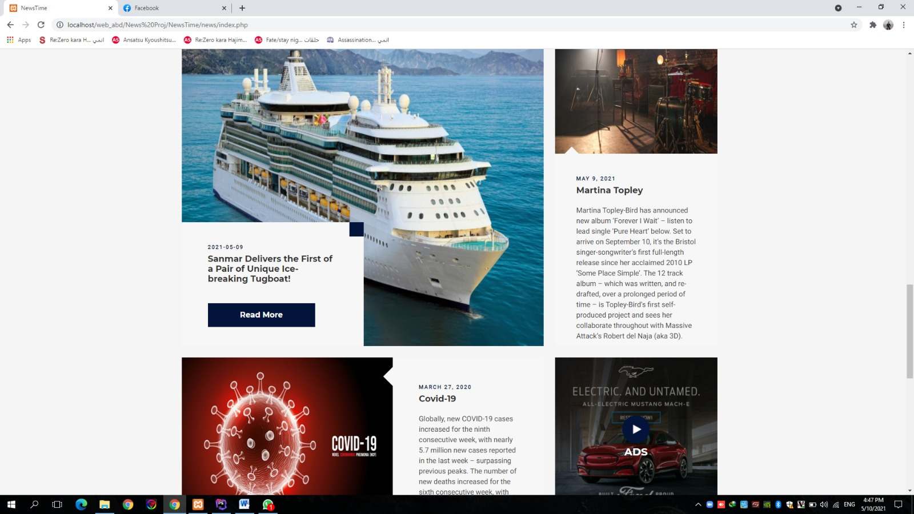

This part of the main page includes recent news block with its all required information and its surrounded by static new with its description , under of it we can see some paid ads.

## **last block and footer of main page**

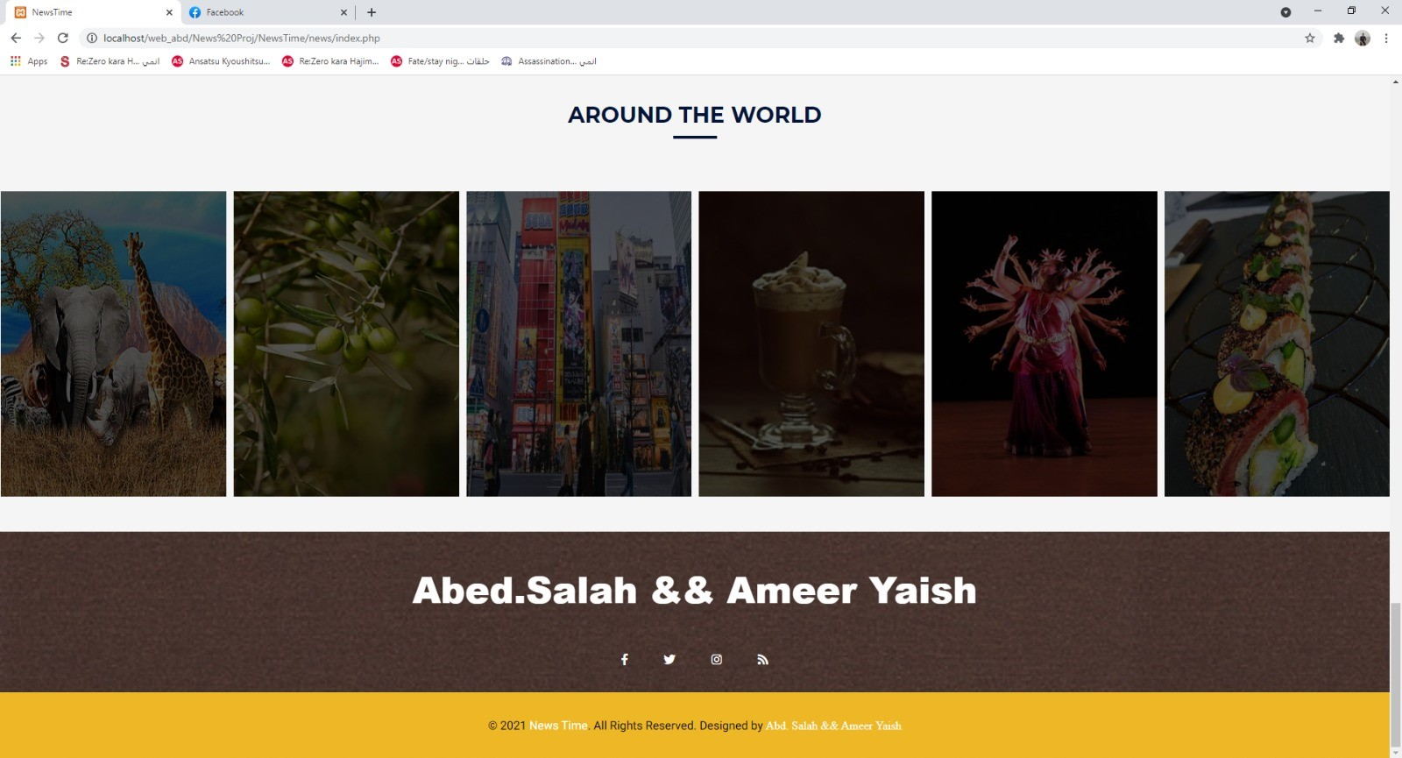

last part of this page contains photos as a gallery denoting to a different countries and its most famous cultures , food and places its widely known by it , if user clicks on any photo he will moves to web site contains required information about these countries cultures .

The footer of the main page has site designers names and there accounts linked by social medias icons.

## **News Sections**

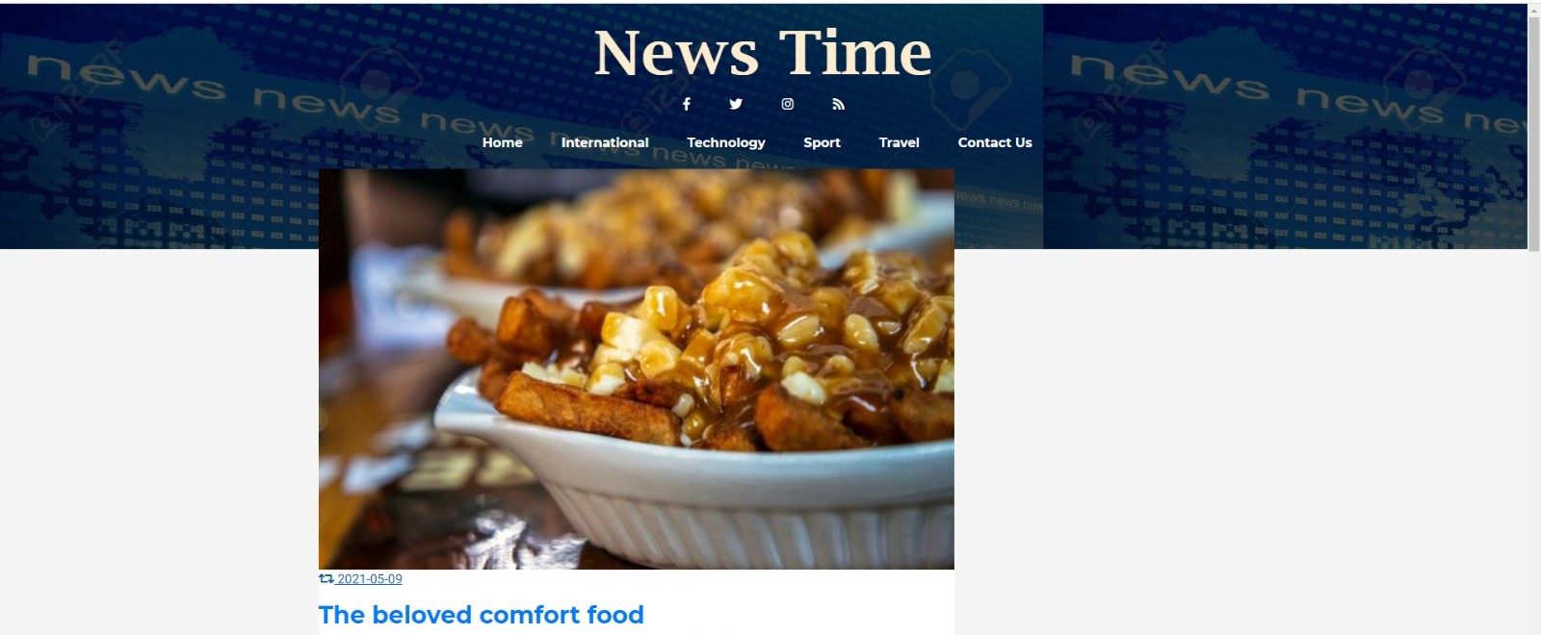

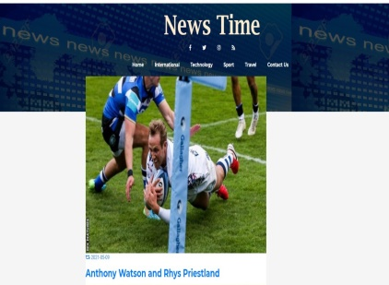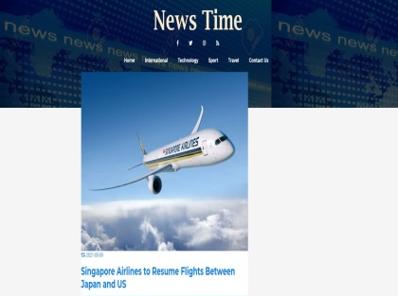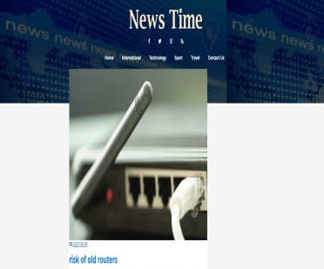

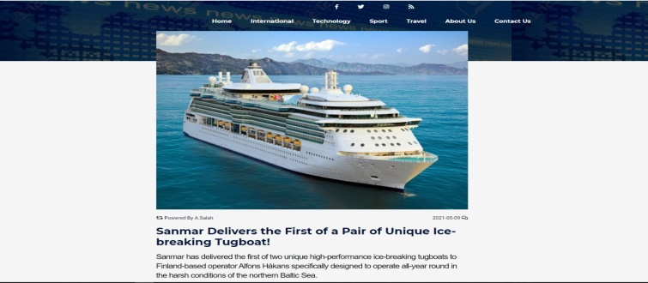

Every section in the main page can be accessed in the header of the page . the content of those sections are their all added news , if the user clicks on the title of the new he will be moved to the content of this new and all information related to it.

## **About us**

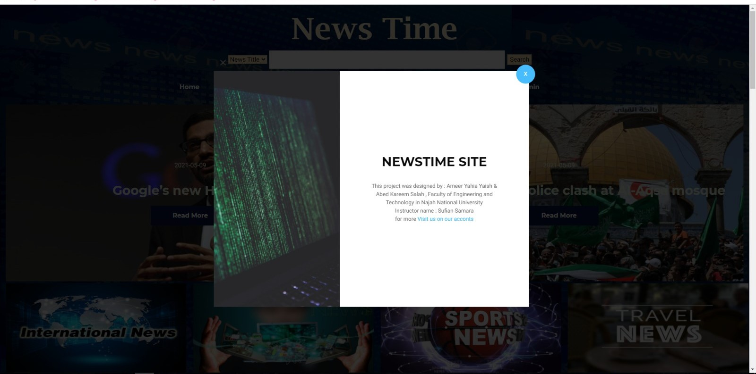

This is about us section , it gives a brief identification for the site designers and their accounts

## **Contact us**

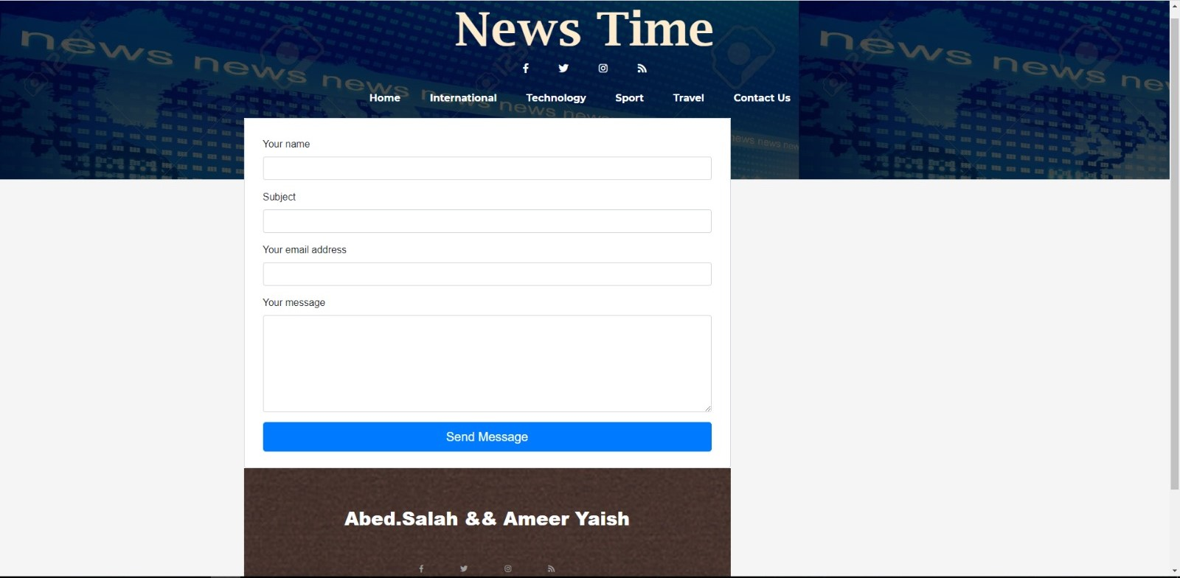

The contact us part of the main page includes a form , if the user wants to message the admins of the site he has to fill the mentioned information about his request.

## **Covid block**

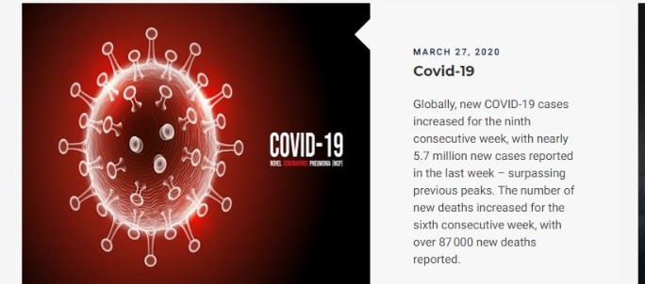

This is a side block in the main page , its linked with a specified page contains some important details presented in a simplified manner and some tips to protect our self from the virus. The page includes a report chart for some statistics.

All of this is illustrated in the next pages.

## **Main covid page**

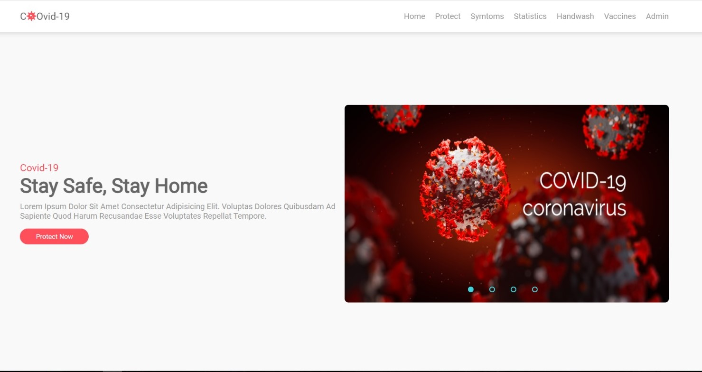

The main page is divided into sections as it clear in the above photo.

## **Protect and Vaccine blocks** **The left pic show the vaccines that infected people should take, for more details click on read more button. In the right pic, some tips we should be aware of to protect our self from being infected by the virus.**

## **Chart and Statistics block** **This chart is a report about different statistics like infected, recovered and deaths by the covid virus. This report can be updated by the user in the control panel and the results will be automatically updated in the above chart.**

## **footer of Covid page the footer contains different locations from the world linked with a web sites about recent covid updates in each country.**

## **Login to control panel Page The login page enables admin and non admin users to move to the control panel page so they can manage users, news, control chart report and see users messages.**

## **Control Panel and Admin Page First section in the control panel allows only admin user to control users accounts, they can add new users and identify their type of administration .**

## **News Control This is the news section, admins can add, update or delete any selected news.**

## **Chart control if the admin wants to update covid statistics he has to insert the new updates in these fields**

## **Contact and users messages This section incudes users messages and their requests descripted by title, email, and body of the message.**

# Conclusion :

This news site allows the user to reach articles from around the world , access it from one place, there is no need to switch between multiple websites to get news from different countries. It's free, unlike buying newspapers. it is distinctive in its simplicity of browsing and managing of news.

What makes it distinguish than other news site that it includes a complete admin page for controlling news and users.

The site stills in test level and can’t be officially published on web because it needs some developments and additional features to take advantage of all its capabilities and that is normal because we are still students and not eligible to develop a perfect site to use due some limits.

# References :

1. web programming slides and lectures by Dr.sufyan samara
2. [www.w3school.com](http://www.w3school.com)
3. <https://fdossena.com>
4. <https://www.chartjs.org>
5. <https://www.youtube.com/watch?v=4jfcxxTT8H0>
6. <https://www.bbc.com/news/in_pictures?fbclid=IwAR2bBb1vBDOx3jGZVPivMJ7JvtAn9VGVgJE7ZCKym3Utl9lcKyUnePjh9ns>
7. <https://unsplash.com/s/photos/news?fbclid=IwAR1_varCxYWhoJWDYIhL86AmS8lMlNx3byJCDVr86GHleEEgAvSQfMhJtx8>
8. <https://www.shutterstock.com/search/news?fbclid=IwAR3Kqo5OCppNuwGm29ocMINrEDXLuso4mkjr7zq1NMhQ7UGrThJ0R69fY4M>
9. <https://www.youtube.com/results?search_query=how+to+make+hover+effects>
10. <https://www.youtube.com/watch?v=wHADuY6sVMg&t=88s>
11. <https://edition.cnn.com/?fbclid=IwAR0_0loA5oHEP-njkBDHnp2ld05xfyr7n0GMO9fov7-8Mh9BPQvKXT8xL38>
12. <https://dribbble.com/tags/login?fbclid=IwAR1bylbPmI0zb8pQWLsFMkQOyL15gXQpaeR-jsN4p97PjtxfNtKLHkT8y_M>
13. <https://www.awwwards.com/awwwards/collections/website-footer-design-best-practices/>
14. <https://dev.mysql.com/doc/refman/5.7/en/innodb-deadlocks-handling.html?fbclid=IwAR2imlDfY0rCp6VXWmFjqmRKpT1oevf2uSkZKV1Hln7AIyl_pirch-aoOWU>